February 26th, 2019
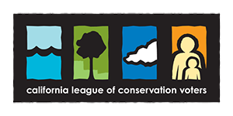
We know it’s hard to track what’s happening in Sacramento -- there are tons of bills and even more votes. But you want to stay up to date on your legislator’s actions on environmental and environmental justice issues, and we’ve got your back.
CLCV's California Environmental Scorecard tracks your legislator’s environmental votes and delivers you the results.
Today we’re launching the 2018 California Environmental Scorecard, and we want you to be the first one to check it out!
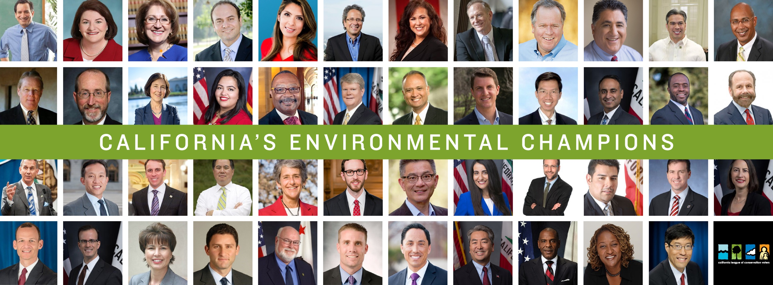
Last legislative session, with your support, we won a number of crucial victories, including protecting our state’s fish and wildlife and passing California’s landmark 100% renewable energy law.
Led by Senate President Pro Tem Toni Atkins and Assembly Speaker Anthony Rendon, who both received 100 percent on this year’s scorecard, we built a strong pro-environment coalition in the Legislature that proves we can fully embrace a clean and resilient future while rejecting the politics of pollution in California. These victories have set the bar for Governor Newsom and our new leadership in Sacramento to set our sights even higher this year with 12 years to act on climate change.
See how your legislator voted on the most important environmental and health legislation impacting California.
When we first launched our print Scorecard 45 years ago, we sent shock waves through Sacramento because it shed light on the legislators who represented their constituents and exposed those who allow the interests of Big Oil and Big Polluters to control our government.
Now, we’re ramping up our accountability work with a fully interactive digital Scorecard to show you how your lawmakers voted on each issue that is most important to you, and to make it easier than ever to call, email, or contact your representatives via social media.
Accountability is key to how we make change. Getting environmental champions elected is one step. Creating transparency on how they perform on our priority issues is just as important. Holding them accountable when they aren’t representing our values is the next step. Our scorecard is a critical tool to ensure our leaders know we’re watching, that we expect them to listen, and that together we will hold them accountable!
That’s why we’re asking you to check the California Environmental Scorecard to see how your legislator performed.
Together, we can hold our legislators accountable to the boldest change possible.
Anything less is not enough.
Thank you for all you are doing to protect our future,
Mary Creasman
Chief Executive Officer
California League of Conservation Voters
P.S. Check out our Facebook Live stream today at 12:30PM to learn more about how to use our scorecard to keep your legislator fighting for the environment.

